Space Cruise (Working Title)

Game Design Document

v.1.0e

Table of contents

1 Section 1 – Game overview 1

1.1 Feature set 1

1.2 Genre 1

1.3 Target audience 1

1.3.1 Number of locations 2

1.3.2 Number of NPC’s 2

1.3.3 NPC description 2

1.3.4 Weapons 2

1.3.5 Items 2

2 Section 2 – Gameplay and mechanics 3

2.1 Gameplay 3

2.1.1 Game progression 3

2.1.2 Objectives – What are the objectives of the game 3

2.1.3 Movement 3

2.1.4 Locks and key cards 3

2.2 Actions 3

2.3 Combat 4

2.4 Successful and failed action print outs 4

2.5 Main Menu and Saving 5

2.6 Walkthrough 6

2.6.1 Part 1 6

2.6.2 Part 2 6

2.6.3 Part 3 6

3 Section 3 – Story, Setting and Character 6

3.1 Story and narrative 6

3.1.1 Back story 6

3.2 Game map 6

3.3 Area #1 - Toilet (start) 8

3.3.1 Possible actions in location: 8

3.4 Area #2 – Hallway 1 8

3.4.1 Possible actions in location: 8

3.5 Area #3 – Supply closet 8

3.5.1 Possible actions in location: 8

3.6 Area #4 – Cabin 1 8

3.6.1 Possible actions in location: 8

3.7 Area #5 – Cabin 2 8

3.7.1 Possible actions in location: 8

3.8 Area #6 – Engine room 8

3.8.1 Possible actions in location: 8

3.9 Area #7 – Hallway 2 9

3.9.1 Possible actions in location: 9

3.10 Area #8 – Crew cabins 9

3.10.1 Possible actions in location: 9

3.11 Area #9 – Cabin 3 suite 9

3.11.1 Possible actions in location: 9

3.12 Area #10 Cabin 3 bedroom 9

3.12.1 Possible actions in location: 9

3.13 Area #11 Cabin 4 presidential suite 9

3.13.1 Possible actions in location: 9

3.14 Area #12 - Final room 9

3.14.1 Possible actions in location: 10

3.15 Area #13 – Control room 10

3.15.1 Possible actions in location: 10

3.16 Area #14 – Storage room 10

3.16.1 Possible actions in location: 10

3.17 Area #15 – Market 1 10

3.17.1 Possible actions in location: 10

3.18 Area #16 – Market 2 10

3.18.1 Possible actions in location: 10

3.19 Area #17 – Market 3 11

3.19.1 Possible actions in location: 11

4 Section VII – Technical 11

4.1 System requirements 11

4.2 Scripting Language 11

4.3 Entity relationships 11

4.3.1 ER Diagram 12

4.3.2 ER Schema 13

5 Section VIII - Management 13

5.1 Detailed Schedule 13

5.2 Budget 13

5.3 Risk Analysis 13

# Section 1 – Game overview

Space cruise is a text adventure game where a player is controlling a lone security guard left behind in a spaceship which is about to be destroyed. The player will acquire helpful items, weapons and keys to get through the ship and reach an escape shuttle to safety. The game takes place sometime in the future.

The spaceship is running on minimum power, so the hallways and rooms only have little light, making the mood chilling.

Using a keyboard, the player inputs words and sentences to move the character and perform different actions. Actions consume time, which is a limited resource, because the ship is heading towards the nearest sun. There is enough time to complete the game, but too much wandering around will result in a game over.

Escape is hindered by locked doors and invading space pirates, who will try to kill the player on sight.

The game is developed with python and it uses a SQL database

## Feature set

Navigating through the ship is done by key card puzzles. By solving problems and finding correct items, the player can get and upgrade existing key cards to open new sectors and advance through the game.

One of the main features is ranged combat by shooting. The player will find several weapons, which will have several levels of accuracy. Different sections (for example, shooting down a distant ladder) can be cleared by comparing gun accuracy to level difficulty and the game will then calculate the shot by these changes. For example, gun accuracy is 4 and difficulty is 3-6. Game will generate a number within the difficulty range (3-6) and if the player’s gun accuracy is at least the same, the shot will be successful. Every shot uses ammo. Ammo isn’t widely available.

Time is measured in moves (movement/commands), you need to finish the game in 70 moves. Commands are +1 and movement is +3, purpose of this time system is to add a little challenge. Energy drinks reduce the moves made by -8 and they are “consumed” as soon as you pick them up.

## Genre

Space cruise is a combination of adventure and puzzle games, with a pinch of action. Adventuring comes from wandering through the spaceship looking for a way out and investigating the environment. The game has several challenge puzzles, for example finding and then upgrading a key card to reach certain rooms. Action comes from the combat sections of the game.

## Target audience

Target audience consists of all types of players, from beginners to long time text adventure players. The game is easy to learn, and the puzzles rely on memory and understanding the environment instead of for example aiming.

### Number of locations

The game consists of 18 locations. Four (4) of these are hallways, thirteen (13) are rooms and there is one escape shuttle.

### Number of NPC’s

The NPCs in the game are all enemies. There are seven enemies in total, which all belong to a “Space Pirate” -category. Individual enemies have small changes in their difficulty.

### NPC description

There are 4 levels on enemy NPC’s:

Level 0: Difficulty 1, no gun.

Level 1: Difficulty 1-3, pistol.

Level 2: Difficulty 2-4, shotgun.

Level 3: Difficulty 3-6, rifle.

All have health of 3

Some may have items on them but it’s not level integrated.

Only purpose of the NPC’s is to kill or be killed.

### Weapons

Three different weapons will be added to the game:

1. Pistol
   1. Starting weapon (from room 4)
   2. Has accuracy of (3)
2. Assault rifle
   1. Second weapon (Room 10)
   2. Has accuracy of (2)
   3. Three shots at a time
3. Shotgun
   1. Third weapon (Dropped from room 14 pirate)
   2. Has accuracy of (3)
   3. Small chance for a critical hit

### Items

1. First aid kit
   1. Restores health.
   2. Can carry one at a time.
   3. “Use *first aid kit*”.
   4. Located in rooms. (X, Y, Z)
2. Energy drink
   1. Restores time.
   2. Consumed on discovery.
   3. Located in rooms. (X, Y, Z)
3. Helmet
   1. Protects head from critical hits. Necessary for room 13.
   2. Automatically equipped on discovery.
   3. Acquired from room 10.
4. Key card
   1. For opening doors. Can be upgraded from terminals.
   2. When interacting with a door, compare key level to lock level.  
      There are cards for levels from 1 to 3.
   3. Located in (X)
   4. Upgrade terminals in rooms. (Y, Z)
5. Grenade
   1. For blasting open one of the stuck doors.
6. Ammo
   1. Usable on all weapons.
   2. Limited resource.

# Section 2 – Gameplay and mechanics

## Gameplay

### Game progression

Game progresses by finding key cards and other necessary items and locating the escape pod room. Helmet is needed to enter room 13 without dying. The player needs to go to room 13 to find an upgrade. The game progresses by finding necessary items and using them in correct places, before the time runs out. Key cards are needed to open various doors and the key cards must be upgraded as you get further in to the game. A grenade is needed to blow up a door that has a broken lock. Once the player has fully upgraded their key card, he/she needs to find the elevator to the escape pod to escape the ship.

### Objectives – What are the objectives of the game

The main objectives are to find key cards and other necessary items to gain access to the escape pod.

### Movement

Movement is done through a pre-set list of locations. “You have access to 1. X, 2 Y, 3 Z…”. Hallways have the points of compass in their name. “East hallway” to help give the player a sense of direction. Direction is critical, because the player needs this information to open the correct doors.

### Locks and key cards

There are two locked doors, at the end of hallway 2 and the door leading to room 9.

Key cards can be found in previous rooms by exploring all the available rooms.

## Actions

1. Look (around)/look at
   1. Player will receive details about the surroundings or specific objects
   2. Do you want to look around or at something specific?
2. Pick up/take + item
   1. Player will receive the item and depending on the item type it will be consumed or equipped immediately or stored for future use
   2. Picked up X
   3. Stored X
   4. Equipped X
   5. What do you want to pick up?
3. Use + item
   1. Player uses a previously stored item
   2. Used X
   3. What do you want use?
4. Open + target
   1. Player opens a door/window/lid
   2. Open what?
5. Close + target
   1. Player closes a door/window/lid
   2. Close what?
6. Move/Enter + number
   1. Player moves to the numbered location
   2. Moved to X
      1. Print details
      2. Move where?
7. Shoot/Fire +(at) target
   1. When in combat player will shoot enemies by the combat rules
   2. Shoot what?
8. Run (away)
   1. Player tries to escape combat. Enemies do not follow.
   2. Escape is successful if randomly generated number from 1 to 10 is greater than enemy difficulty
9. Save game/save
   1. Saves the game so it can be continued at another time
   2. Saving is prevented while in combat
   3. Saving overwrites the previous save
10. Search/investigate + target
    1. Player searches the targeted container/item

## Combat

Whenever the player faces an enemy turn based shooting combat will start. Combat will follow the following rules:

1. IF the player has no weapon, he is killed on sight
2. IF there are more than one enemy AND the player doesn’t have a helmet, he is killed on sight
3. IF the player is facing an enemy and HAS a weapon, gun accuracy is compared to enemy difficulty
   1. For example, Pistol with accuracy of 2 vs enemy difficulty of 4
4. Number from 1 to “enemy difficulty” is randomly generated. IF “number” <= gun accuracy = successful shot
5. IF the player HAS a weapon AND a helmet the enemies are battled one at a time

Player has a base health of 10

Pirates have a base health of 3

## Successful and failed action print outs

Use grenade on “x”:

Door 1 in location 8: “You blew up a door holding back the flood, you drowned”

Door to location 11: “Door is now open”

Anything else: “That’s not a good idea.”

Use med kit:

If health is not full: ”Health is now (health + 2)”

If health is full: “No need for that”

Take helmet:

“You put on a helmet”

Take keycard:

“Your keycard level is now (keycard level + 1)”

Take ammo:

“You found 10 bullets”

Take “anything but: grenade, ammo, pistol, shotgun, rifle, keycard, helmet, energy drink, medkit”:

“There’s no need for that”

Search/investigate:

Body: “You found: (items carried by that enemy)”

Search/investigate/look at:

Toilet: “It’s empty.”

Sink: “There is “X” in the sink. “

Container: ”There are sheets and pillows”

Look at:

Mirror: “You see yourself, there are bags under your eyes and a penis drawn to your forehead”

Map: Shows map

Monitor:” Flood on North and North-east of the ship, doors on lockdown”

Info panel: ”Destination -Alpha Centauri- ”

TV: ”Snakes on the plane is playing”

Control panel: ”It’s a broken touchscreen”

Shelfs: ”There is ”X” on the shelfs”

Save/save game:

“You saved the game”

In combat: “You cannot save the game while enemies are around”

Shoot/fire:

At anything else but the enemy: “Don’t do that, you’ll just waste ammo”

If you die:

Because of not having a helmet: “You died… if only I would have had a helmet.”

Because no health left: “You died.”

Because blew up the wrong door: “You blew up a door holding back the flood, you drowned”

Because time ran out: “You ran out of time, the ship is in the stars orbit and escaping is too late”

If you win:

“You made it to the escape pod… Home here I come.”

## Main Menu and Saving

When starting the game application, a main menu is displayed first. There are two options, which are “New Game” and “Load Game”. If no saved game exists player will be told “No saves available, please start a new game.”

The game can be saved anytime, except in combat. Saving is done by “Save game” command. This is instructed at the beginning of the game.

## Walkthrough

Saving frequently is advised, since the game can suddenly end after a false choice or a lost fight. Monitor your health and use med kits when necessary.

### Part 1

Pick up the keycard. Open the door and move to hallway. Look at map on the wall. Step to the engine room and investigate the info panel (to get information about east wing having no air and west wing being under assault). Step back to hallway, move to Cabin 1, Pick up the pistol and ammo, then step back to hallway. Open the door to supply closet and pick up a key card and a med kit. Use keycard on lock by the door on the end of the hallway. Move to the second hallway.

### Part 2

Open door to crew cabins, pick up the grenade and step back to hall. Use the cleaners key card to open the door to a suite. Continue to the bedroom and pick up the helmet. Step back to the room and drink an energy drink. Go back to the hallway, use the grenade on the locked door to a presidential suite.

### Part 3

Move to the presidential suite and fight a space pirate. Pick up a shotgun and a med kit. Continue to next room and defeat the next pirate. Continue to storage room, defeat a pirate and pick up an assault rifle. Go back to the previous room and continue forward. Defeat another pirate with your new weapon. Continue forward and clear the enemies before stepping into the control room. Face both enemies one at a time. Move to the emergency exit and escape the ship in a shuttle.

# Section 3 – Story, Setting and Character

## Story and narrative

### Back story

After the last cruise on a cruise ship a security guard is accidentally left behind when the ship is set to the nearest star for demolition. During its trip the ship has received damage to one side, resulting in the area to not have any air. On the other side of the ship, space pirates have invaded, and are looting everything valuable. Our character must now navigate his way through the ship and get to the escape shuttle before it’s too late.

## Game map

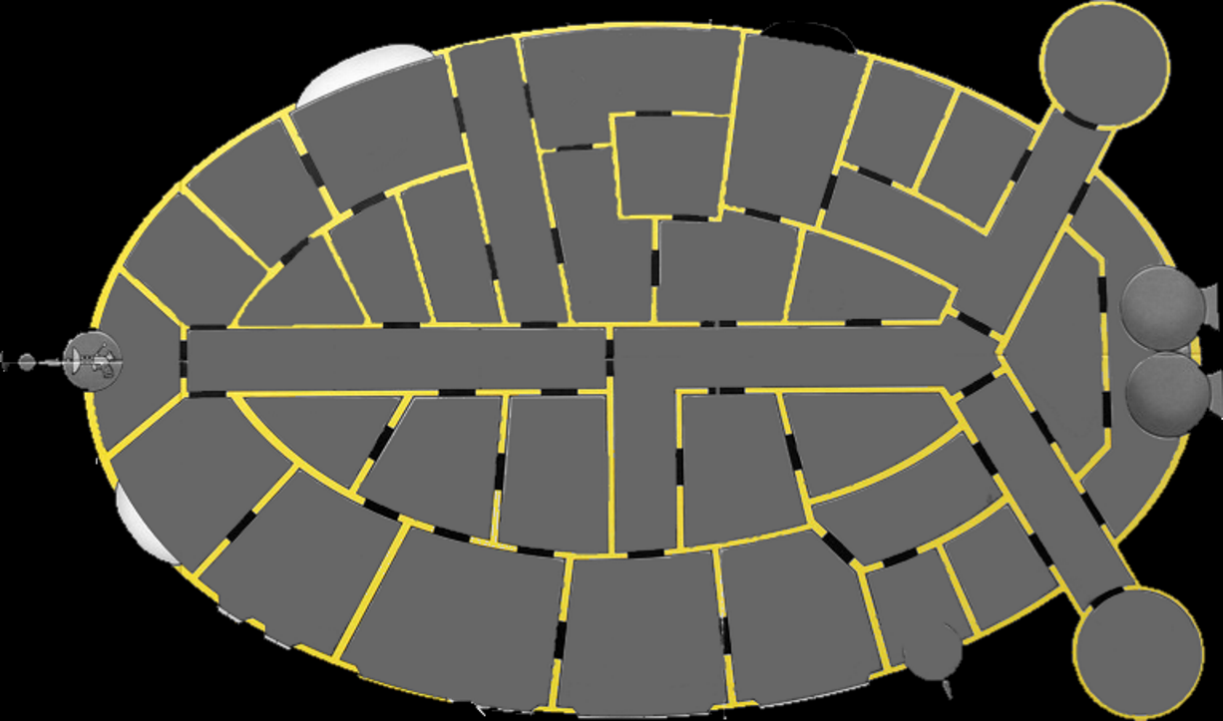

1. Picture - Map layout

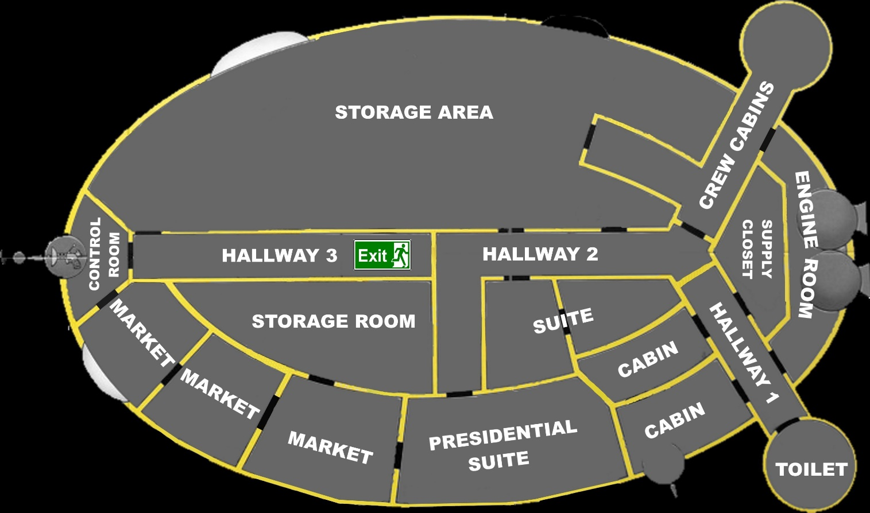

2. Picture in-game map

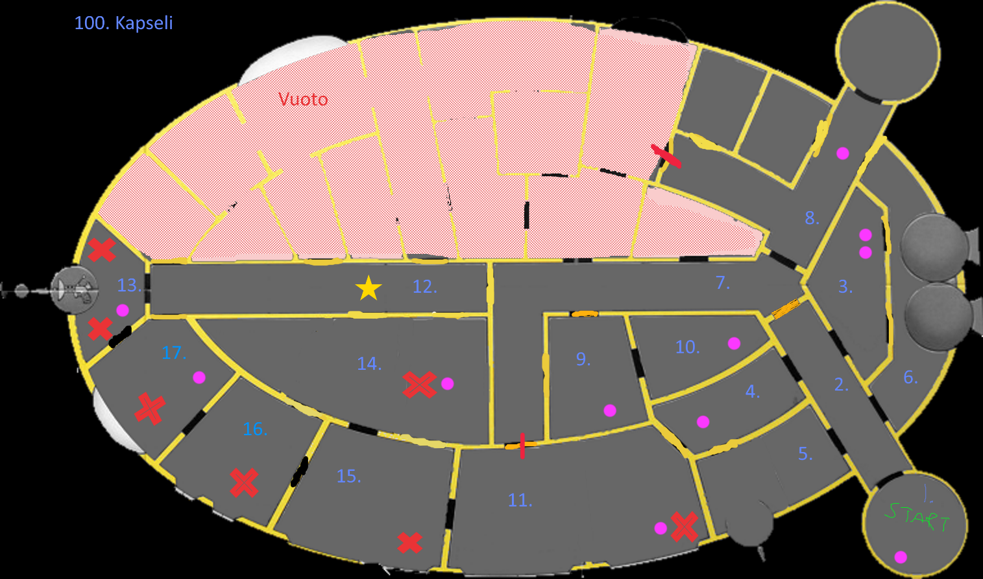

3. Picture - Detailed map

Purple dot = An item

Red cross = An enemy

Black line = a Door

Orange line = a locked door

Yellow lines = walls

Red line = Grenade use point

Pink area = Inaccessible area

Grey area = Accessible area

## Area #1 - Toilet (start)

Starting room: You wake up in a public bathroom.  
There are toilets and sinks, there is a key card on one of the sinks.

### Possible actions in location:

Pick up/take key card; look at toilet/sink; Go to 2

## Area #2 – Hallway 1

Hallway 1: It’s a hallway with 5 doors. There is a map on the wall.

### Possible actions in location:

Look at map; Go to 1/5/6/4/3.

## Area #3 – Supply closet

Supply closet: It’s a small closet with some mops and other cleaning equipment on the left. One of the mops has a key card hanging from it. The wall on the right has a med kit.

### Possible actions in location:

Take key card/mop/cleaning equipment/med kit; Go to 2.

## Area #4 – Cabin 1

Cabin: There is an unmade bed on the left, in front of you there is a mirror, and on your right, a small bathroom.

Go to bathroom; There is a pistol with some ammo in the sink

### Possible actions in location:

Look at mirror; Go to bathroom/2.

In bathroom: Take pistol/ammo; Look at sink.

## Area #5 – Cabin 2

Cabin: There is an unmade bed on the left, in front of you there is a mirror, and on your right, a small empty bathroom.

### Possible actions in location:

Look at mirror; Go to 2/bathroom .

## Area #6 – Engine room

Engine room: There is a big engine system with bunch of monitors blinking red saying “Flood at North and North-east part of the ship, doors on lockdown.” Info panel reads “Destination Alpha Centauri” …. Hmmm…. Isn’t Alpha Centauri the nearest star from here.

### Possible actions in location:

Look at monitors/info panel; Go to 8/2.

## Area #7 – Hallway 2

Hallway 3: It’s an L shaped hallway with 6 doors.

### Possible actions in location:

Go to 8/9/11(if opened); Open 11 with grenade; Use grenade on 11.

## Area #8 – Crew cabins

Crew cabins: It’s a V shaped hallway, with two doors and a lounge. The door where you came from and one to the rest of the crew cabins. The second door is shut, and you can hear a loud strange noise behind it.

There is a single grenade on a table.

### Possible actions in location:

Go to 7/door 1/door 2; Take grenade; Use grenade on door 1; Open door 1 with grenade.

## Area #9 – Cabin 3 suite

Suite: There is a bathroom on the right, couch and a tv in front of you and on your left, there is bedroom.

Go to bathroom: There is a toilet, a shower and a sink, and on the sink, there is an energy drink.

### Possible actions in location:

Look at tv; Go to bathroom/10/7.

In bathroom: Look at toilet/shower/sink; Take energy drink; Go to 9.

## Area #10 Cabin 3 bedroom

Suite bedroom: There is a large bed that has a pistol, ammo and a helmet on it …Seems like there were some weird people on this cruise, good that I didn’t run into them yesterday…

### Possible actions in location:

Take pistol/ammo/helmet; Go to 9.

## Area #11 Cabin 4 presidential suite

Presidential Suite: There is a space pirate with a shotgun tearing down the room.

Kill pirate/space pirate with a rifle/pistol: There is a corpse with a shotgun in front of you, on the right a bathroom and on the left a large bed and a living room area.

Bathroom: there is a med kit on the counter.

Run: You’re back in the hallway.

### Possible actions in location:

Shoo/fire at space pirate; Run

After killing the pirate: Investigate body; take shotgun; Go to bathroom/15/7.

Bathroom: Take med kit.

## Area #12 - Final room

Hallway 4: There is an elevator

(pre-set option (if you have the correct key card)) Enter elevator: The elevator leads to the escape pod…. Home here I come…. Game ends

### Possible actions in location:

Go to elevator/13.

## Area #13 – Control room

Control room: (If you have a helmet) There are two space pirates, one of them shoots you in the head, you instinctively shoot him back and he dies, there’s still one pirate left.

Kill pirate with (gun): There are two bodies on the ground, in front of you there are broken control panels.

(No helmet) There are two space pirates, one of them shoots you in the head, you die.

### Possible actions in location:

Shoot/fire at space pirate; Run.

After killing the pirates: Look at control panel; Investigate body (both at the same time); take key card/shotgun; Go to 12/17.

## Area #14 – Storage room

Storage room: There are see through containers filled with sheets and such everywhere. You see a moving pile of sheets close to you, a head pokes out of it, and it’s a space pirate

Kill pirate with (gun): There is a corpse wrapped in bloody sheets, on the table next to him there is an assault rifle, on the shells there are containers filled with sheets, pillows and cleaning products (no point in taking any of it).

### Possible actions in location:

Run; Shoot/fire at space pirate.

After killing the pirate: Look at container; investigate body; Take pistol; Go to 15.

## Area #15 – Market 1

Market 1: There is a space pirate going through the store…  
This shouldn’t even faze you anymore…

Kill pirate with (gun): There is a corpse next to you, the shelves around the store are mostly empty, with one energy drink on the shelves.

### Possible actions in location:

Run; Shoot/fire at space pirate.

After killing the pirate: Investigate body; Look at shelves; Take energy drink/shotgun; Go to 16/11/14.

## Area #16 – Market 2

Market 2: There is a space pirate going through the store, he just found something interesting (Key card) and is totally caught off guard.

Kill pirate with (gun): There is a corpse in front of you, the shelfs around the store are empty…How did this guy not hear the shooting next room? …

### Possible actions in location:

Run, Shoot/fire at space pirate.

After killing the pirate: Investigate body, take keycard, Go to 17/15.

## Area #17 – Market 3

Market 3: A space pirate tries to shoot you, but his first shot just misses your head.

Kill pirate with (gun): There is a corpse next to you, the Shelfs around the store are mostly empty, medkit on the counter.

### Possible actions in location:

Run, Shoot/fire at space pirate.

After killing the pirate: Investigate body; take rifle/med kit, Go to 13/16.

# Section VII – Technical

## System requirements

OS: Windows.

Memory: More than 0 MB.

Graphics: Optional.

CPU: Any metal slab with electricity.

Sound card: Make beep and pew noises with your mouth when needed.

## Scripting Language

Python and SQL.

## Entity relationships

The character is in a map square and can carry items. Character has set values of health and time which can decrease and increase through the game. Combat difficulty is used to calculate shots from and for the enemies.

Map squares are marked with coordinates, which other entities use in their data.

Enemies are in a set map square and have the same attributes as the playable character, except time.

Items have their own stats regarding its possible effect on health points, attack accuracy and time. One item can have one or more attributes. Most items are in a map square, some are held by enemies.

### ER Diagram

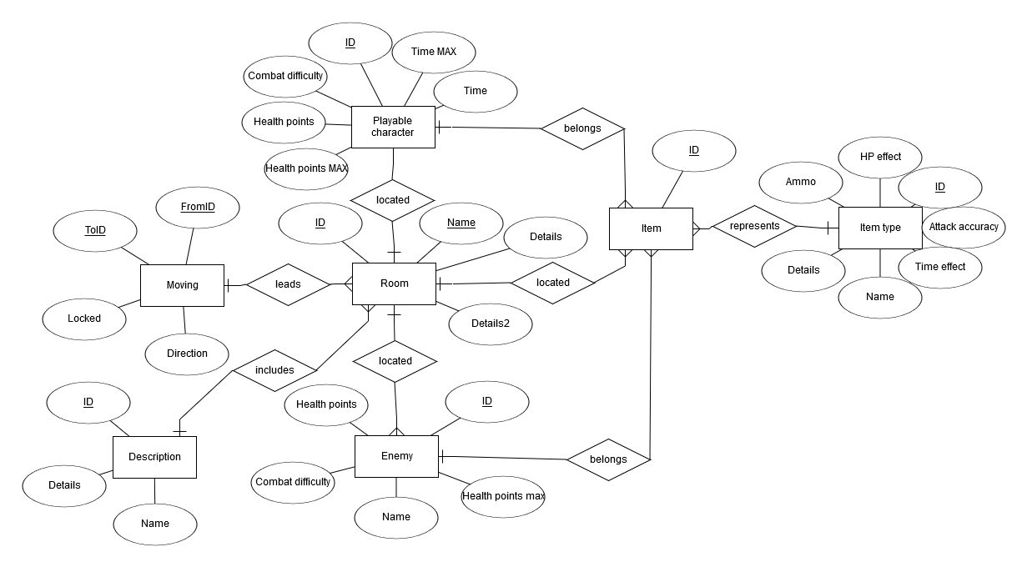

3. Picture: ER Diagram

### ER Schema

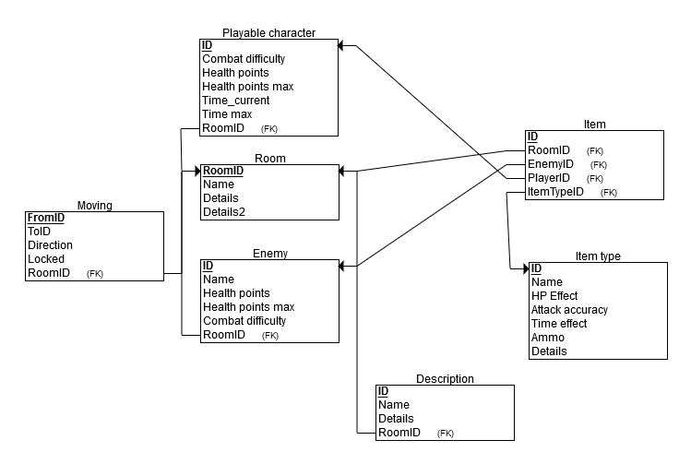

4. Picture - ER Schema

# Section VIII - Management

## Detailed Schedule

GDD release on 11.2.2017.

Game release TBA.

## Budget

0€

**Business expenses:**

- Two discount subs á 6,90.

Total:13.80€

## Risk Analysis

Possible loss: Hundreds of hours of work from the team.

Possible (probable) gain: Getting 5/5 grade from this class.